Superstore Sales Analysis
- Project Overview
The Superstore Sales Analysis project focuses on analysing retail sales data to identify business trends, product performance, and profitability insights. The analysis was performed using SQL, Power BI and Python to clean, transform, and visualize the data effectively.
The main objective of this project was to help understand how different categories, regions, and customer segments contribute to overall sales and profit, and to identify areas where the business can improve performance.
- Dataset Summary

- Rows: - 9994
- Columns: - 21
- Key Records:
  - Order ID
  - Customer Name
  - Product Category
  - Sales
  - Profit
  - Quantity
  - Region
  - State
  - Shipping Mode
  - Order Date
The dataset was cleaned before analysis to remove duplicates, handle missing values, and standardize data formatting.
- Business Problems Analysed
The project focused on answering the following business questions:
- Which product categories generate the highest sales?
- Which regions contribute the most profit?
- What is the monthly sales trend?
- Which customer segments are the most profitable?
- How does shipping mode affect profit?
- Which sub-categories perform best and worst?
- Does high discount increase sales?
- Which customers purchase repeatedly?

- Cleaning Data & Missing Values

- Data Loading: Importing dataset using Pandas.
- Initial Exploratory: Used df.info() function to check structure, df.describe() for summarize statistics and df.null() function to check any missing values in dataset.

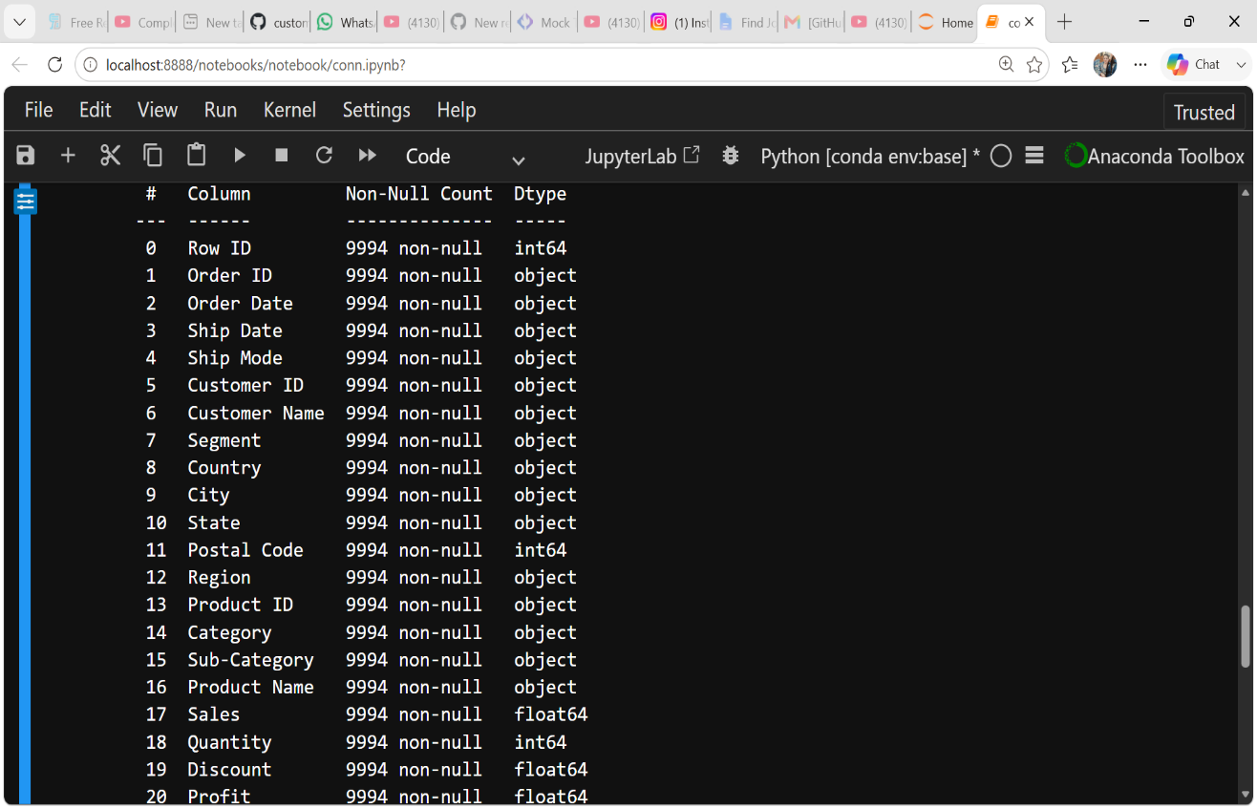

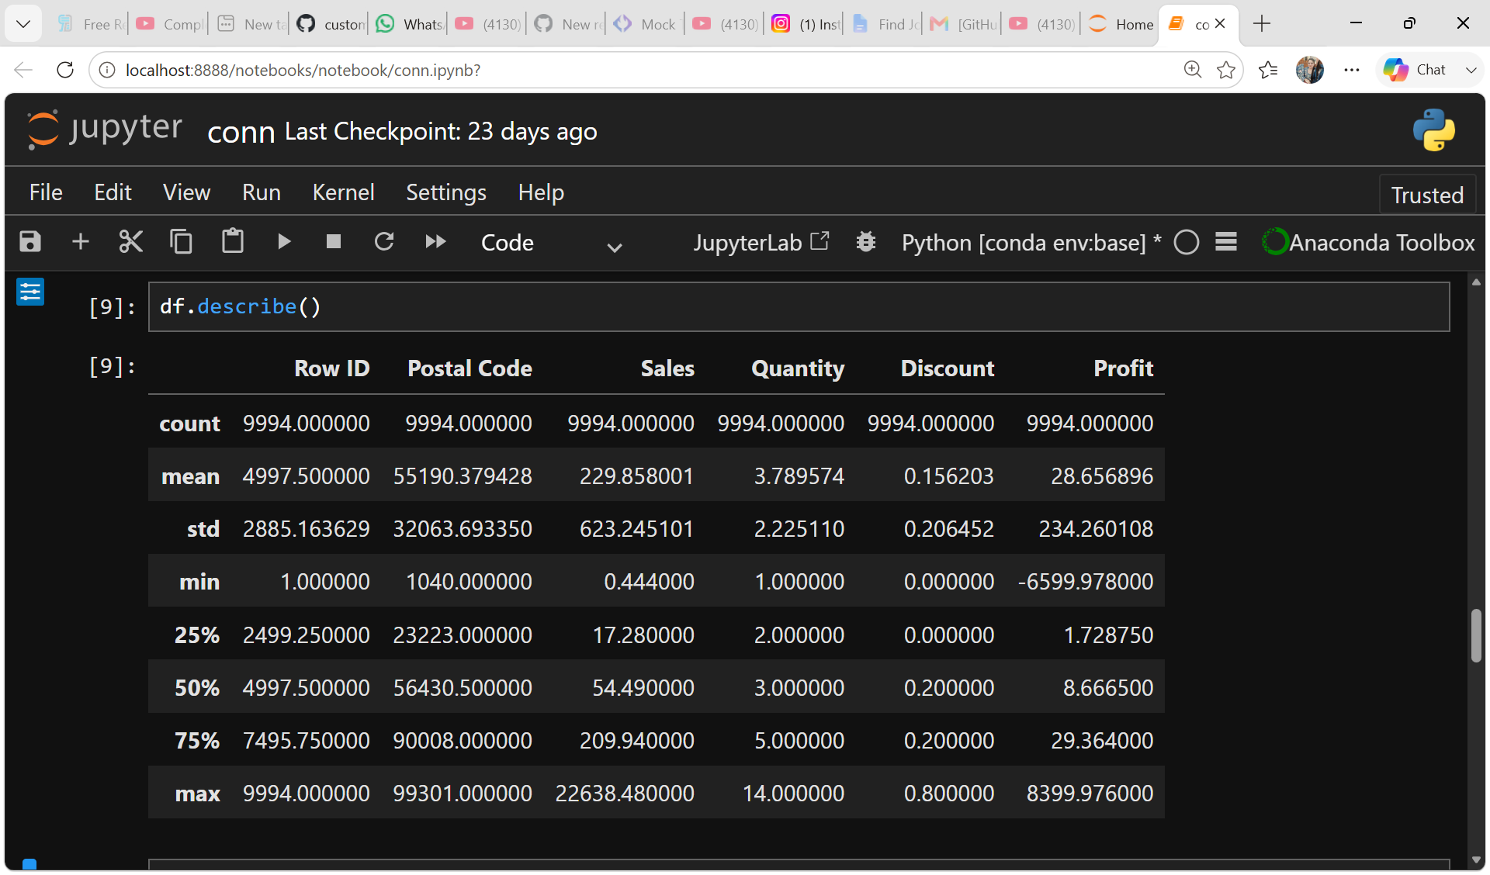

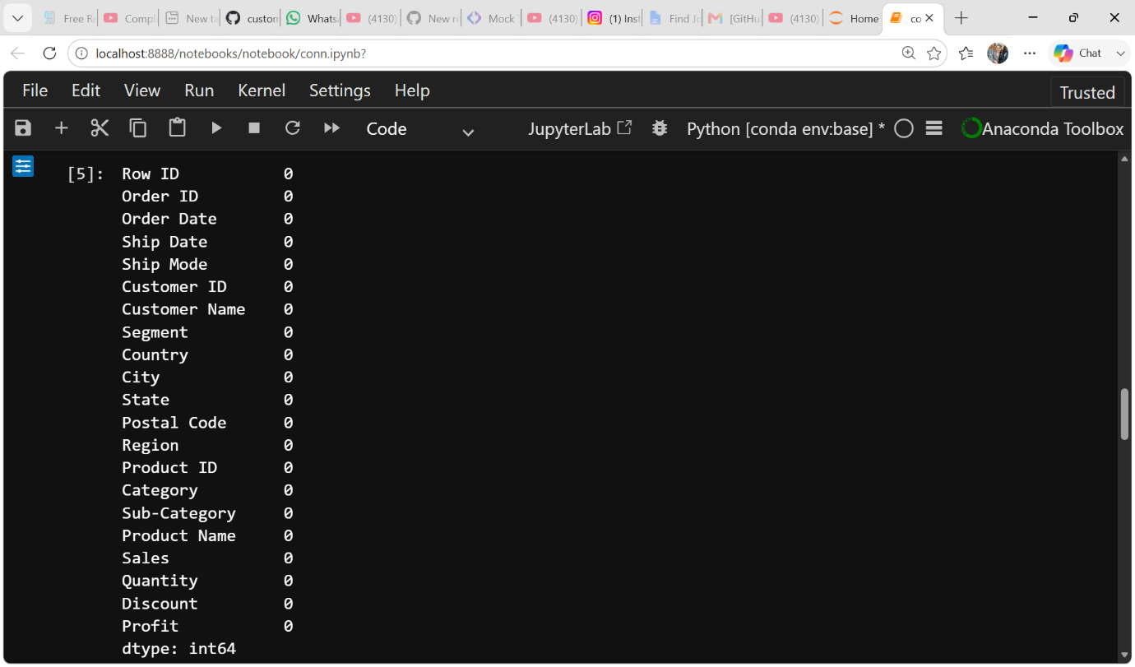

- Data Analysis using SQL
Performed structured analysis in PostgreSQL to answer key business questions:
      - Product category by highest sales: Checking which product has highest sales.
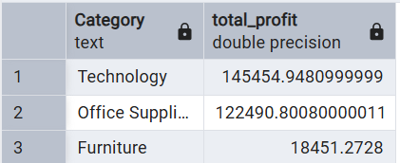
      - Regions by most Profit: Found which region gained highest profit.
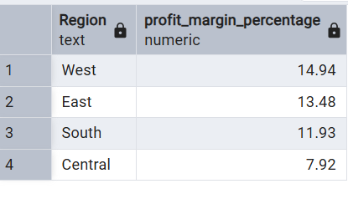
      - Month-wise Sales: Compared sales trend increase or decrease by months.
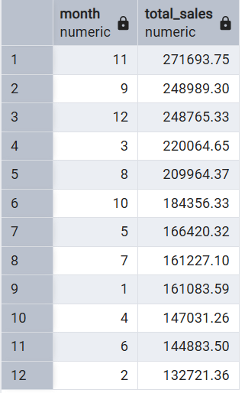
      - Customer Segment by profit: Found which customer segment generated highest profit.
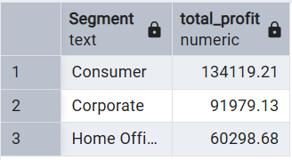
      - Shipping mode by profit: classified shipping mode into Standard class, Second class, First class and Same day.
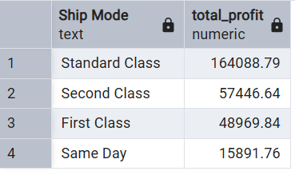
      - Sub-Categories by Performance: Identified which categories performed best or worst.
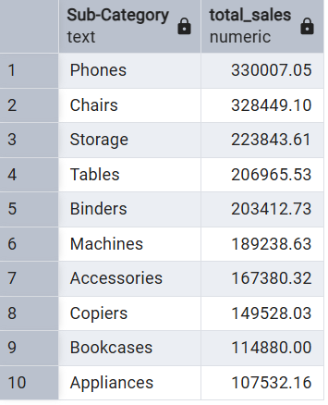
      - Sales increase by discount: Identified that higher discounts led to higher sales.
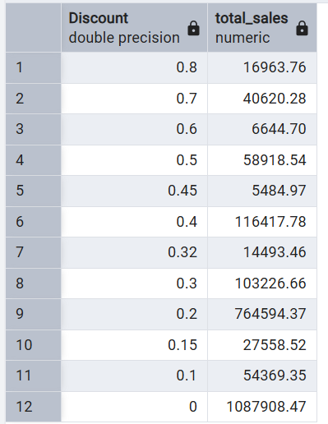
      - Customer by Repeatedly Purchase: Analysed customer purchase patterns to identify repeat customers.

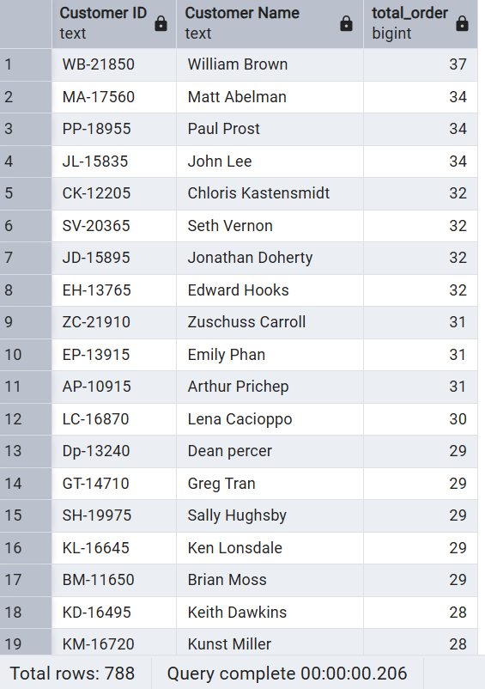

- Dashboard in Power Bi
Finally, we build an interactive Dashboard in Power BI to represent insights visually.
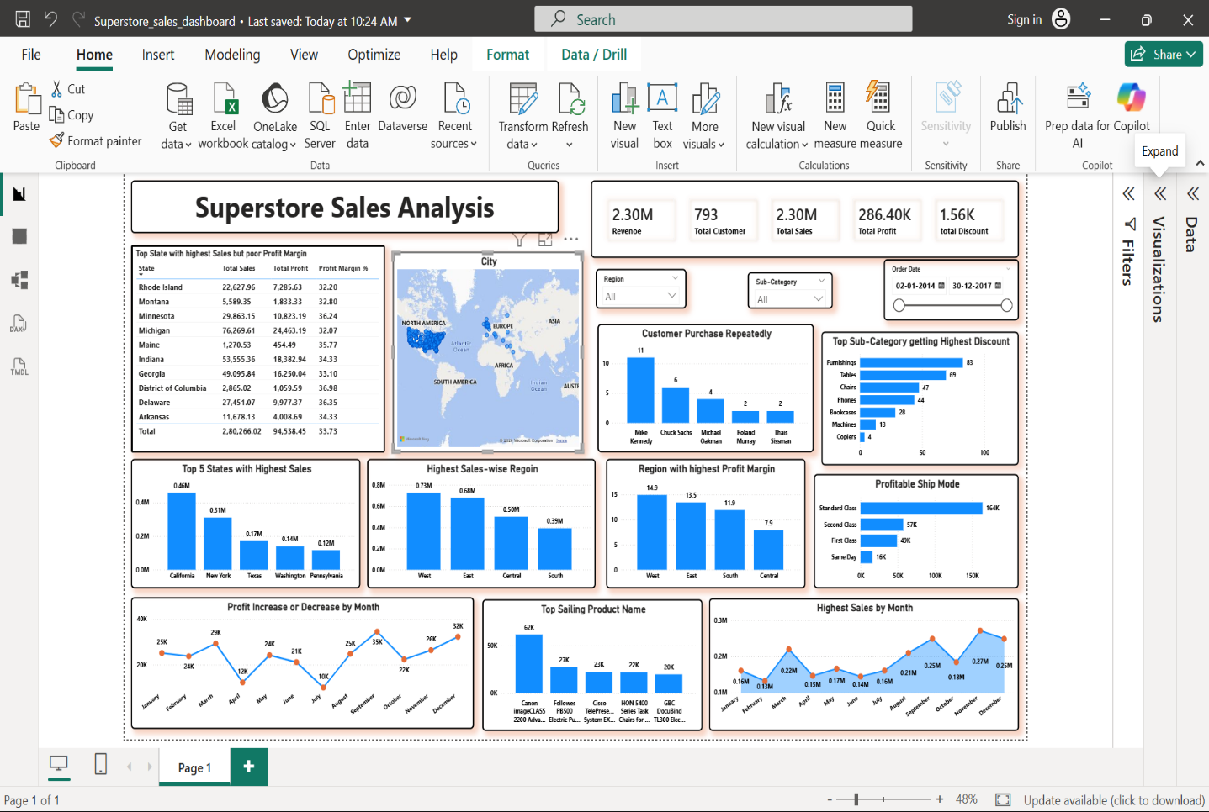

- Business Recommendation

          - Reduce excessive discounts on low-profit products to improve overall profit margins.
          - Improve sales strategies in low-performing regions to increase profitability.
          - Optimize shipping methods to reduce operational and delivery costs.
          - Monitor product-level profitability regularly to improve pricing strategies.
          - Analyse customer purchasing behavior to create targeted marketing campaigns.

